Human ICT Software Engineering Subject

**SimpleMerge Project Report**



Team 19

Written and Revised by Yang Insu

Version 1.0

**Table of Contents**

1. Software Architecture Design
2. Implementation
3. Testing
4. Results
5. Aftermath

**I. Software Architecture Design**

**1. Requirement Analysis**

The first job of the project was indicating all the possible use cases of the future program during the 1st workshop. For the details, please refer to the SRS document.

**2. Domain Modeling**

1) Domain Model v1.0

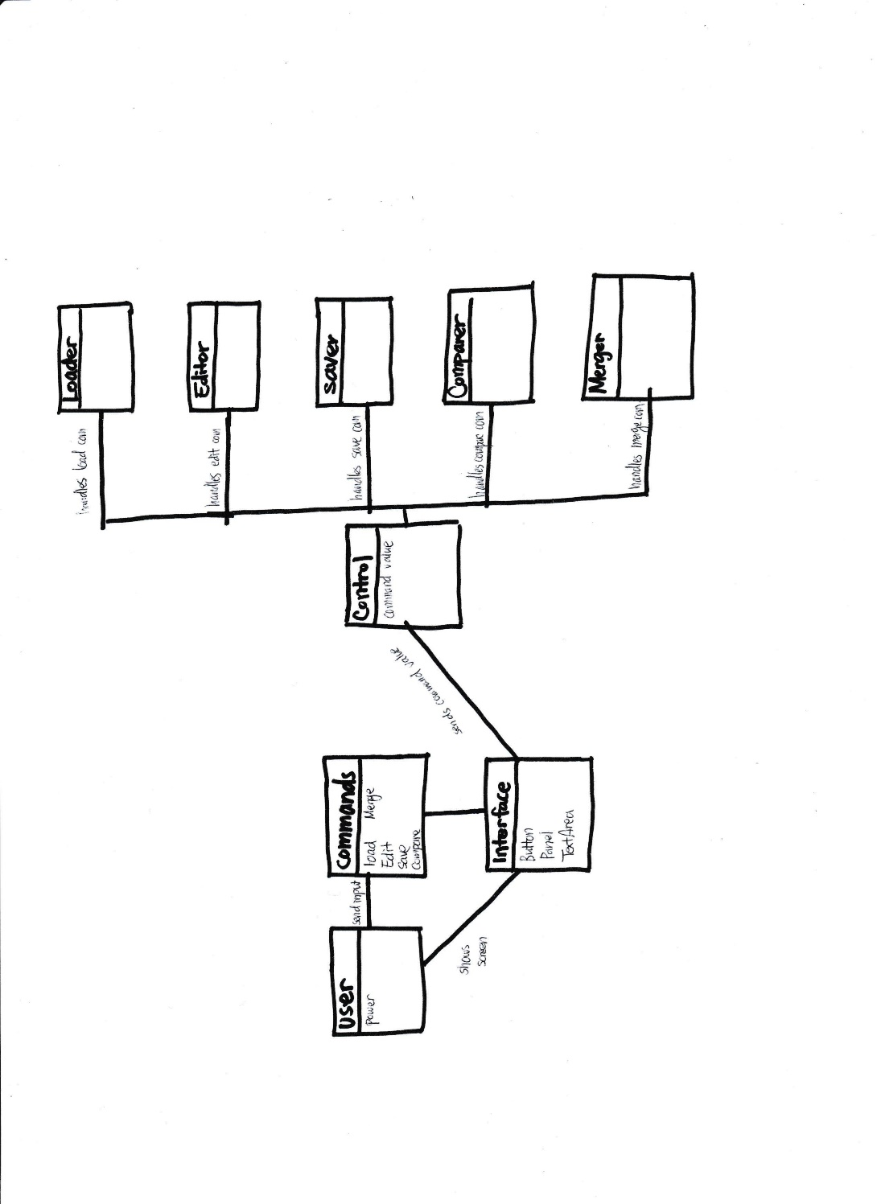

After searching for all possible use cases, the nouns in the scenarios that were potentially to become classes in the implementation were selected to become components of the domain model. The boundary that was set for this domain model was extended to the outside region of the program, until the user.

1. Component Description:

User: user was created as a class, because during the 1st workshop, the program was thought to have potential for having its own class to save any kind of user information.

Commands: domain for saving the user’s inputs to the program, which are basically commands to the program was considered for linking the user and program together.

Interface: A separate class for interface was considered to show only the outer layers of the program to the user, and keeping the implementation parts hidden. (Encapsulation) The interface component should have attributes that later become GUIs.

Control: Control domain was created to by overlook the flow of logic of the functionalities. Control domain receives the commands of the user, then sends messages to the corresponding domain that handles the requested function.

Loader, Editor, Saver, Comparer, Merger: these domains are handlers of the program. When these components receive requests from the Control, the requested function is invoked then returns the results to the user.

1. MVC Concept

The idea of separating Interface, Control, and the handler classes was an endeavor to apply MVC concept to the project.

Handler Domains <-> **M**odeling

(Loader, Editor, Saver, Comparer, Merger)

Interface Domain <-> **V**iewer

Control Domain <-> **C**ontrol

By separating these three components, implementations for functionalities on early stages of the project iteration and testing them separately became possible.

1. Object Oriented Concept

Making the interface was thought to fulfill the requirements for encapsulation, so that the user would not have touch any of the interior implementations to utilize the program.

2) Domain Model v2.0

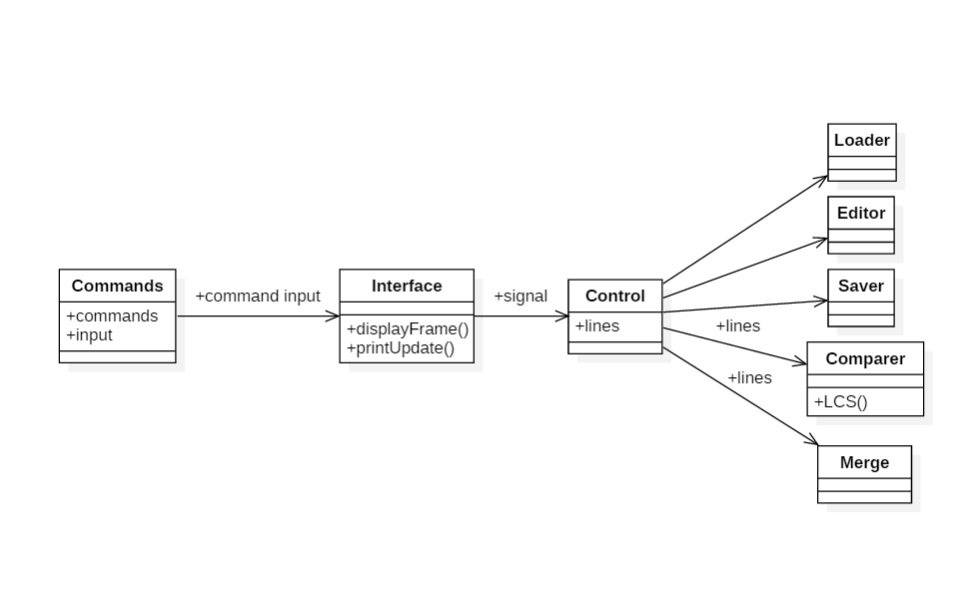

User component was erased at this stage of refinement, due to the fact that there is no need for any user related data to be saved nor used. Unit test was planned during this stage in two parts: checking each classes if they have received parameters correctly, and Comparer domain using LCS algorithm.

Since Load, Edit, Save are related with exterior files, no specific functions were planned to be implemented except for testing for successful parameter receiving.

1. Component Description

Commands: Command was implemented as a class to contain commands: options that the user can indicate (load, edit, save, compare, merge). Also inputs are saved in this class for the Comparer.

Interface: displayFrame() is a function that shows the result of Compare.

Control: Passes lines (which are saved in Commands as input) to Comparer.

Loader: not yet specified at this level.

Editor: not yet specified at this level.

Saver: not yet specified at this level.

Compare: Receives lines from the controller, then compares differences using LCS algorithm.

Merge: Receives lines from the controller. (specific function not yet to be implemented. )

1. MVC Concept

Commands domain was maintained to act as the “Model” in the MVC concept. Therefore it was kept from other domains such as Interface and Controllers to change the contents of the model.

1. Object-Oriented Concept

The idea of inheritance between Controller and Handler components was considered due to its similarities and its closely related functionalities. However since applying Graphical User Interface was fixed to be implemented, we planned ahead that the Handlers would be extensions of ActionEvent classes, not the Controller class. Finally deciding that there would not be any inherits relationship in the entire program.

3) Domain Model v3.0

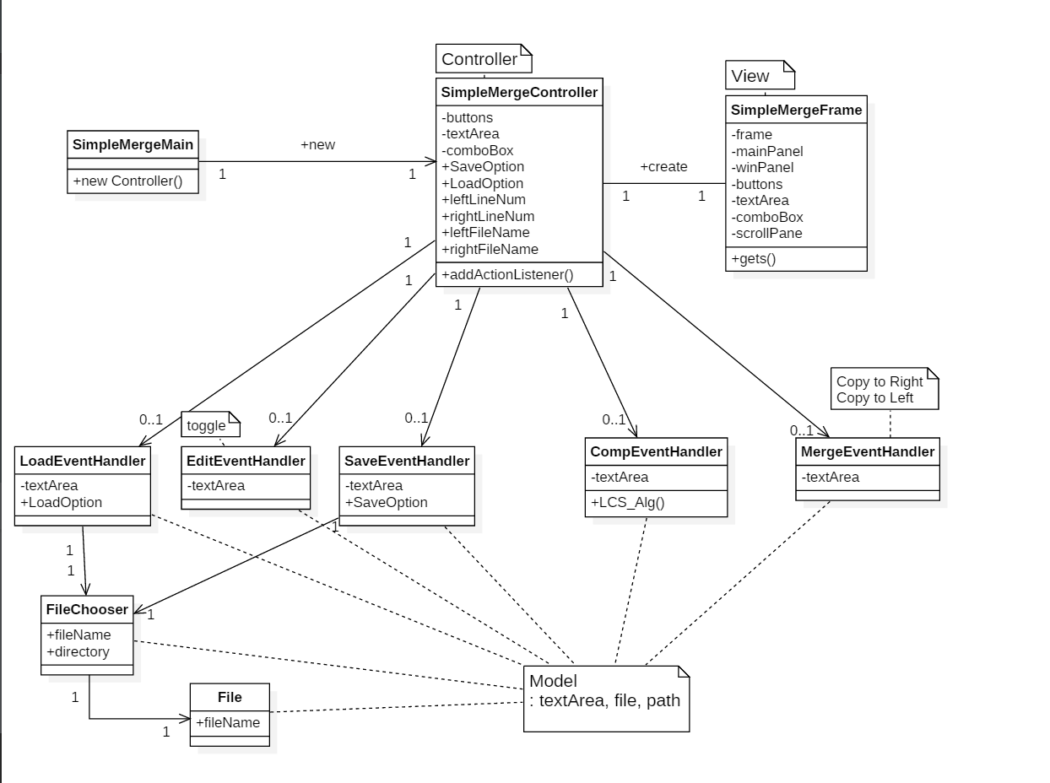

GUI concept is now introduced, therefore the entire structures of the domain is changed. Since all the inputs by the user are now handled by buttons in the GUI, any flow of inputs are deleted, and flow of class instantiation is now the main flow of the Domain model.

1. Component Description

SimpleMergeMain: This is the main class for the entire program. The main function instantiates controller class.

SimpleMergeController: First creates a frame instance, which creates a window for the user to facilitate functions via GUI. After the GUI is created, the following instance controls the functions that the user has called upon. (in means in actual usage, clicking the buttons)

SimpleMergeFrame: Acts as the Interface domain that was in the previous versions. SimpleMergeFrame’s function limits itself only in making the GUI visible to the user.

LoadEventHandler: Implements extensionally from the ActionListener interface, and shows the user expected results of the Load feature.

EditEventHandler: Implements extensionally from the ActionListener interface, and shows the user expected results according the “edit” action. (clicking the EDIT button)

SaveEventHandler: Implements extensionally from the ActonListener interface, and saves the file in the wanted directory.

CompEventHandler: Compares the textArea’s contents via LCS algorithm, and displays the results in the panel visible to the user.

MergeEventHandler: Merges different parts of the two textAreas.

1. MVC Concept

During the first domain models, the interface acted as a linkage between the control and user, however during implementation, a problem was faced where the Interface domain also dealt with parts of the Controller’s role. Therefore the structure was refined where the new Frame instance, which deals with the view role purely.

Now, the model becomes data files, which are not very visible in this stage of diagram, because the model is now the textfiles that are loaded by the Controllers, and copied to the textArea of the GUI.

1. Object-Oriented Concept

The method of implementing the Handler components were decided at this stage of iteration, to use the interface concept (Inheritance) to utilize ActionListener interface from the imported ActionEvent class.

Changing the structure where Controller precedes Frame in instantiation is intended to maximize Single-responsibility principle. The previous version allowed a flaw in structure where the Interfaces engaged in Controller related responsibilities. The Interface received strings that were meant to be used by the Controller. Therefore separation of roles was devised, and resulted in complete separation of roles in the two classes.

**3. Class Diagram**

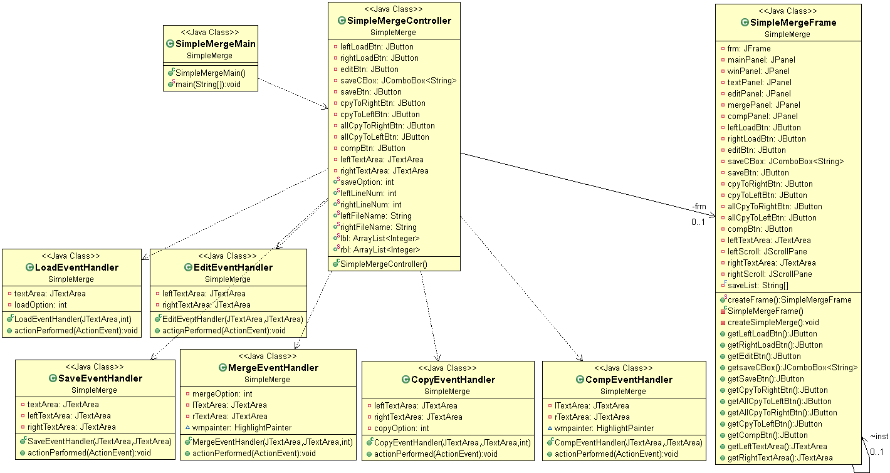

After updating the domain models, the final format is of the classes were set for implementation. CopyEventHandler is added to support an additional feature, copying the entire file to the wanted region.

1. Component Description
2. MVC Concept
3. Object Oriented Concept

**II. Implementation**

**1. Load**

A. System Sequence Diagram

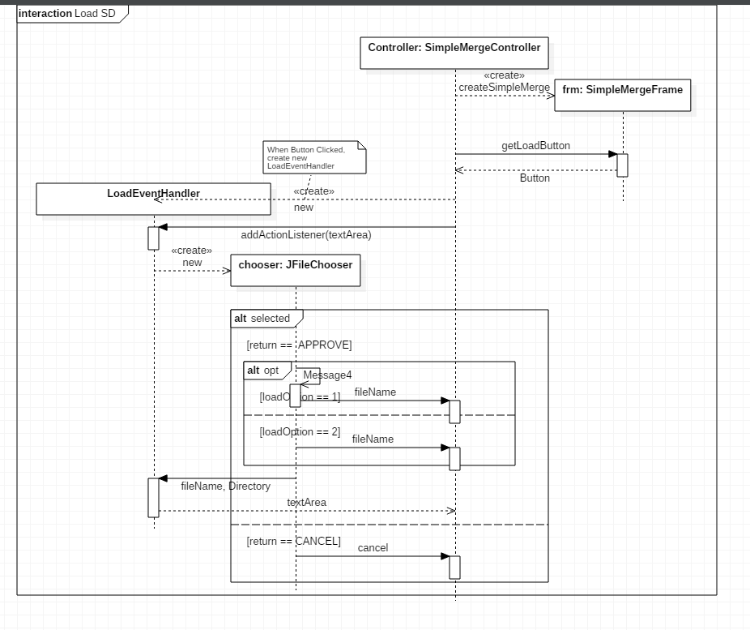

Full System Sequence Diagram for Load Feature

* Following Diagram describes entire Load feature both left and right.

Description:

Premise) main function from the main class creates Controller instance

1. Controller instance creates frm instance of SimpleMergeFrame class.
2. Controller requests for the member variable LoadButton and getLoadButton() sets the LoadButton value identical to the same named variable in the frm instance.
3. LoadEventHandler instance is then created by Controller instance, passing textArea as a parameter.
4. LoadEventHandler invokes JFileChooser instance chooser (provided library class) allowing the user to choose wanted text file from the local disk directories
5. Combined Fragment: (only one sequence of the following two is executed)
6. if return value of the selected file is APPROVED (the file has been accepted to open)

return the filename to the Controller, and following text file is opened in the panel.

1. if return value of the selected file is CANCEL, return cancel (or error) to Controller. There is no text file in the panel.

B. Actual Code Implementation

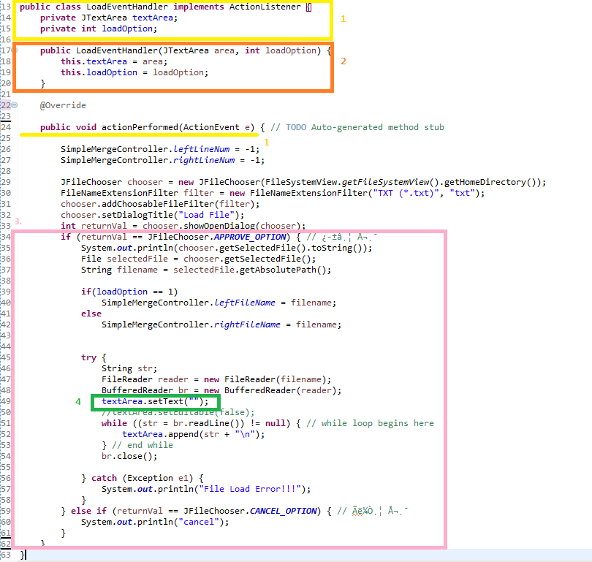

Description:

1. Dependency of LoadEventHandler Class



We imported exterior component ActionListener interface (provided by JAVA).



Then used overriding method to implement our own custom function to perform the Load function corresponding to the requested command.

1. textArea’s Role as Controller

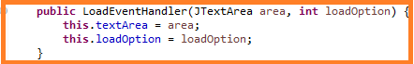

LoadEventHandler acts as a sub-controller for Load case for the Controller instance. Therefore LoadEventHandler class receives access to textArea.

1. Functional Logic Flow

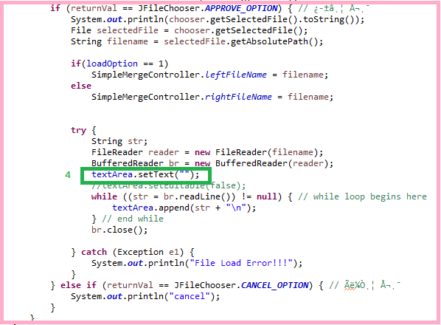

The logical flow of the main function of LoadEventHandler was implemented identical to the logic previously planned and explained in the System Sequence Diagram. (Load Case). The overridden function checks the returnVal of the JFileChooser’s APPROVE_OPTION value, and depending on that option, the function accepts the chosen file, or cancels the Loading operation. Next, when the file is approved to accept, then loads the file according to the loadOption value. If the load Option value is 1, then it means the file chosen goes to the left panel, otherwise right.

1. Exceptional Situation Handling



This line of code prevents appending of contents when LoadEventHandler’s actionPerformed is invoked multiple times.

**2. Edit**

A. System Sequence Diagram

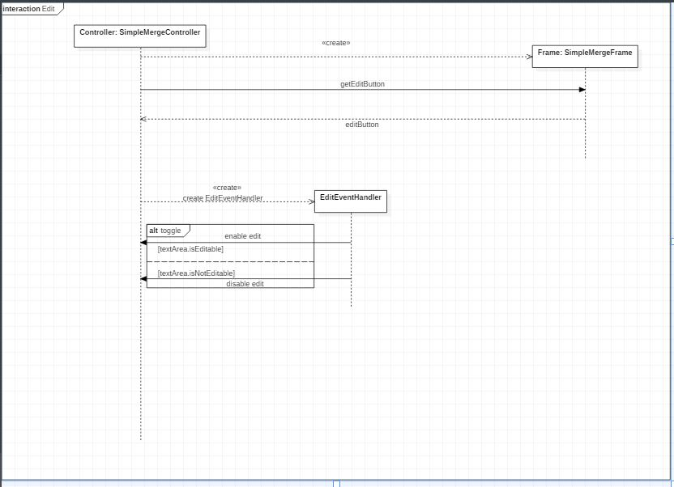

Description:

Premise) Main Class’s Function creates Controller Instance.

1. Controller instance creates Frame instance.
2. Controller receives editButton from Frame instance.
3. SimpleMergeController creates EditEventHandler instance.
4. Depending on the value of textArea’s variable (isEditable, isNotEditable), EditEventHandler toggles textArea.

B. Implementation

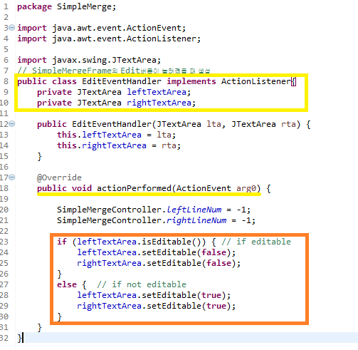

Description:

1. Dependency of EditEventHandler



EditEventHandler implements the ActionListener interface.



Structural form is identical for all sub-controller classes (handlers).

1. Logic for Edit Feature

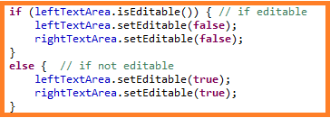

The logic for editing is identical to the System Sequence Diagram. The implementation was based on the planned logic.

**3. Save**

A. System Sequence Diagram

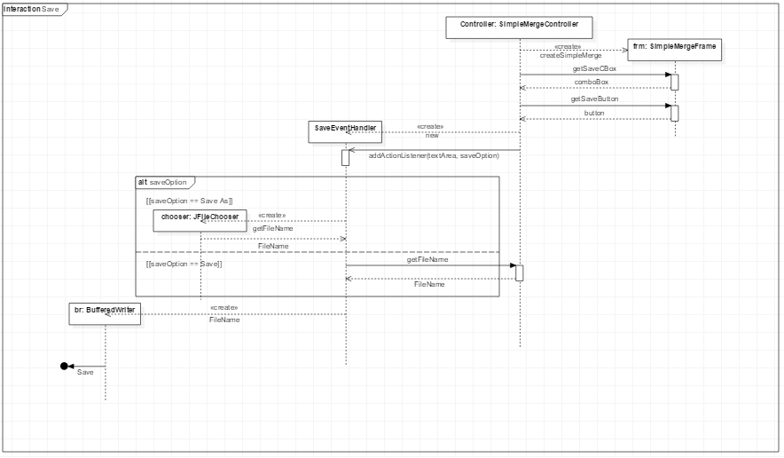

Description

Premise) Main Class’s Function creates Controller Instance.

1. The user selects saveOption and press save button.
2. Sets the FileName, Directory.

i) If saveOption is “Save”, get the FileName, Directory from the SimpleMergeController.

ii) If saveOption is “Save As”, get the FileName, Directory from chooser.

1. Save it with the specified FileName and Directory.

B. Implementation

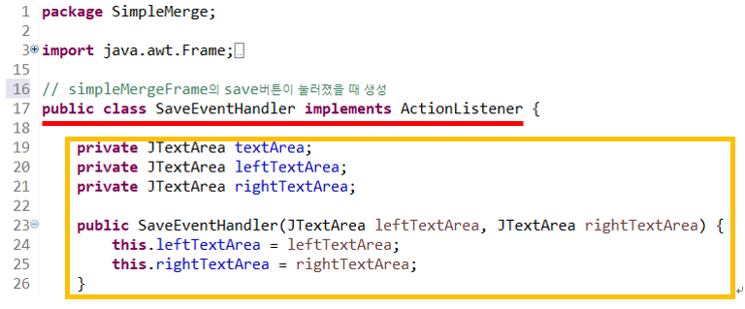

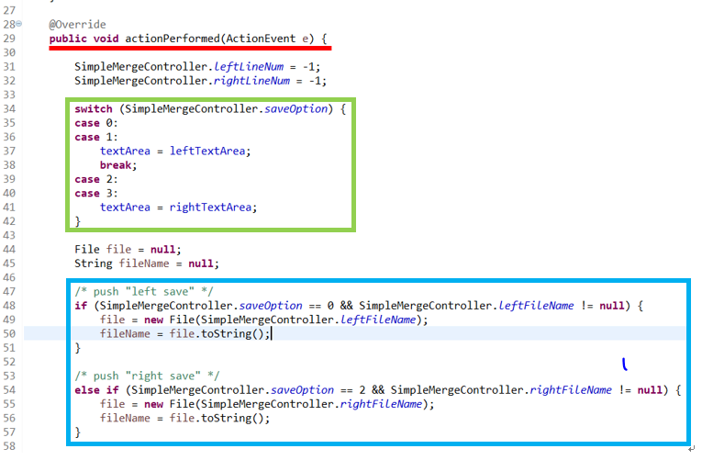

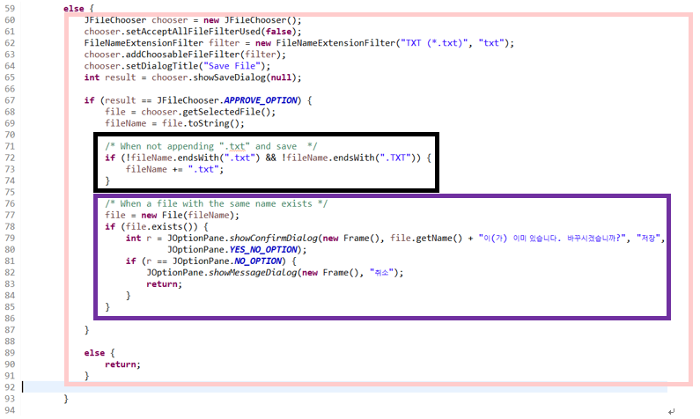

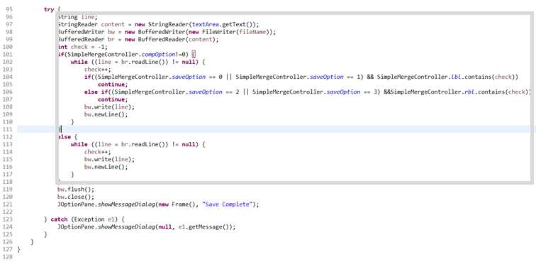

Description:

1. Dependency of SaveEventHandler



SaveEventHandler implements the ActionListener interface.

1. textArea’s Role as Controller

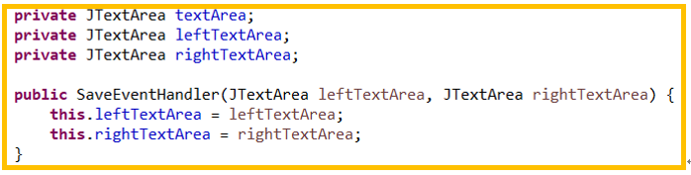

SaveEventHandler acts as a sub-controller for Save case for the Controller instance. Therefore SaveEventHandler class receives access to textArea.

1. Save Option ( left save, left save as, right save, right save as )

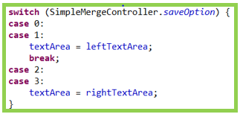

We read the variable of SimpleMergeController to distinguish between left storage and right storage. And put the appropriate textArea in the class variable textArea.

1. Situation ( push “save” button after “load” button)

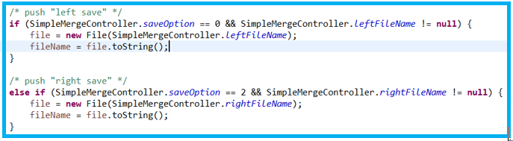

Takes the file location of the load from SimpleMergeController and save the contents of textArea.

1. Exceptional Situation Handling ( Not appending “.txt” and Save )

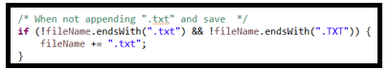

If you append “.txt” and press save button, save as is. But If you don’t append “.txt” and press save button, append “.TXT” at the end and save.

1. Exceptional Situation Handling ( Same name file exists )

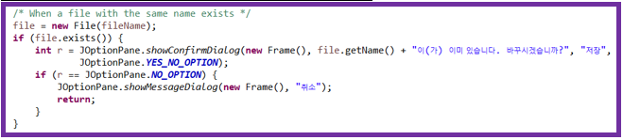

When saving, if there is a file with the same name, a new Frame() is opened to select whether to overwrite or cancel.

1. Functional Logic Flow

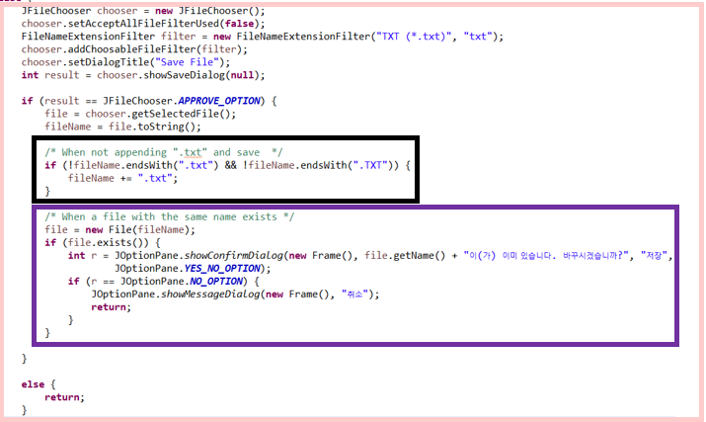

A window titled “Save File” will be displayed.

Specify the location to save.

Set the file name to be saved.

Press button to save. Only “.txt” files can be formatted.

1. Exeptional Handling for Saving ( When you press the “save” button with a fake space created after pressing the “compare” button )

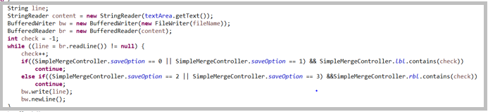

In this situation, we ignore fake space and save it in a file.

**4. Compare**

**5. Merge**

**6. Compare**

**7. Interface**

**III. Program Testing**

1. **Abstract Interface Test**

During the 2nd and 3rd cycles of our elaboration stage, testing was preceded before moving on to implementing GUIs. The main purpose of this test is to figure out if parameters from different classes are passed correctly.

1. CreateFrame()

This method was implemented to check if it successfully created the to-be implemented 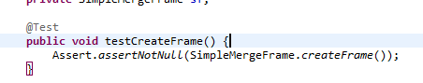frames of the GUI.

.

1. 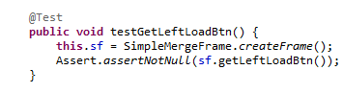GetLeftLoadBtn()
2. 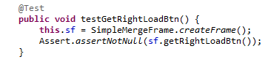GetRightLoadBtn()
3. 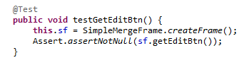GetEditBtn()
4. 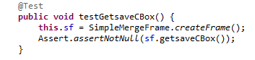GetsaveCBox()
5. 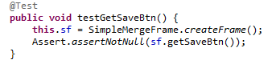GetSaveBtn
6. 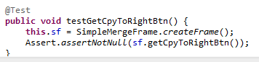GetCpyToRightBtn()
7. 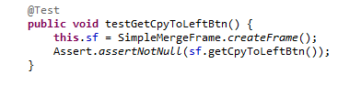GetCpyToLeftBtn()
8. 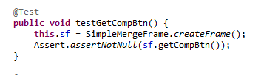GetCompBtn()
9. 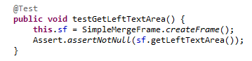GetLeftTextArea()
10. 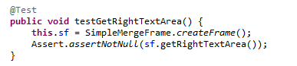GetRightTextArea()
11. 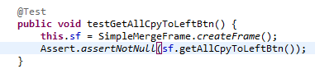GetAllCpyToLeftBtn()
12. 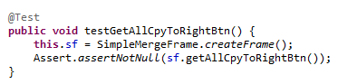GetAllCpyToRightBtn()

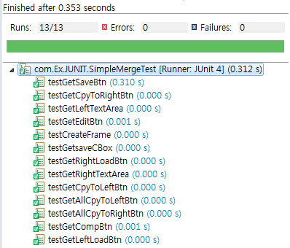The results indicate successful testing results.

1. **Compare Logic Test**

The most important logic in the functional areas of the program is the Compare feature. LCS Algorithm was adapted to check for different lines of the given input stream of characters, therefore before implementation of the Compare class, and its functions, it was considered critical that unit testing be done on the self designed LCS algorithm.

We ran the test results in 20 different cases to clearly see the verification of the LCS algorithm. (lines are represented as one character)

1. 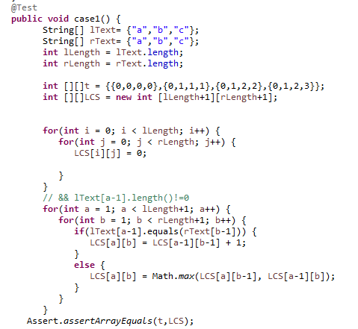Case 1: All lines are identical
2. Case 2: Only one line different
3. Case 3: One of the files have blank line
4. Case 4: One different line, one blank line
5. Case 5: All lines are different.
6. Case 6: 2 different lines

**IV. Results**

**1. Execution**

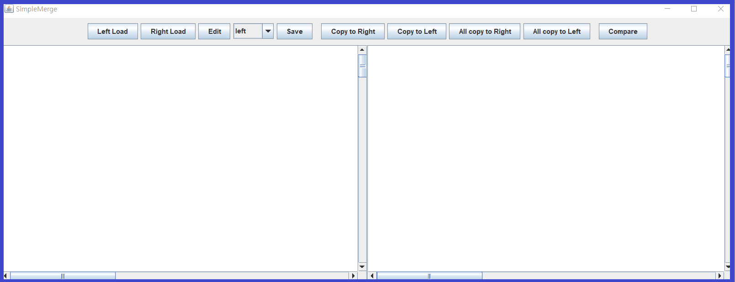

1) Run SimpleMergeMain

- Program displays View (SimpleMergeFrame).

**2. Load**

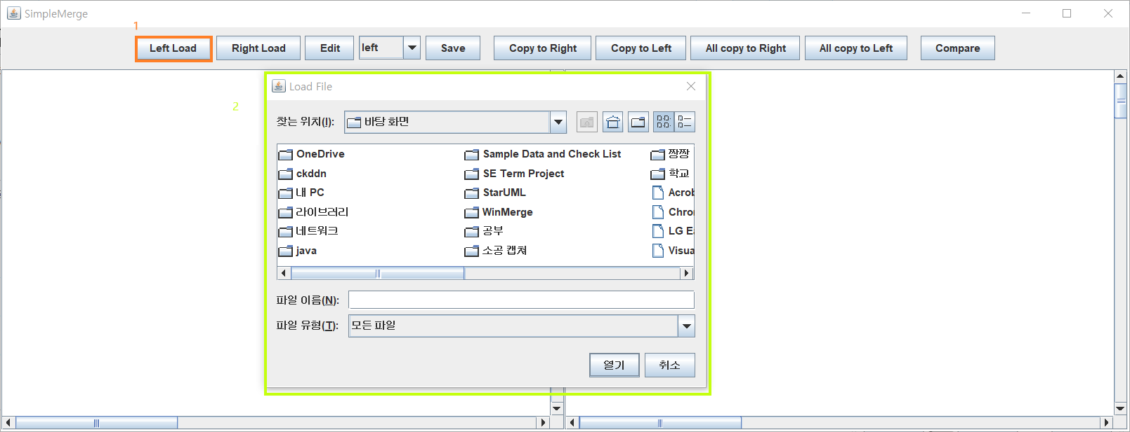

1) Press Left Load Btn

- Press “Left Load” button.

- FileChooser frame for load file to left panel evoke.

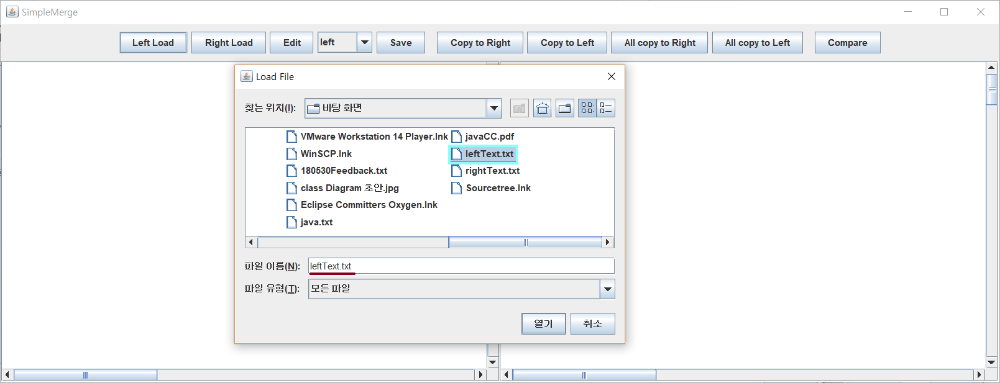

2) Select File and Press Open Btn (Left)

- select file from filechooser frame.

- selected file name recorded in filename label.

- press “열기” button.

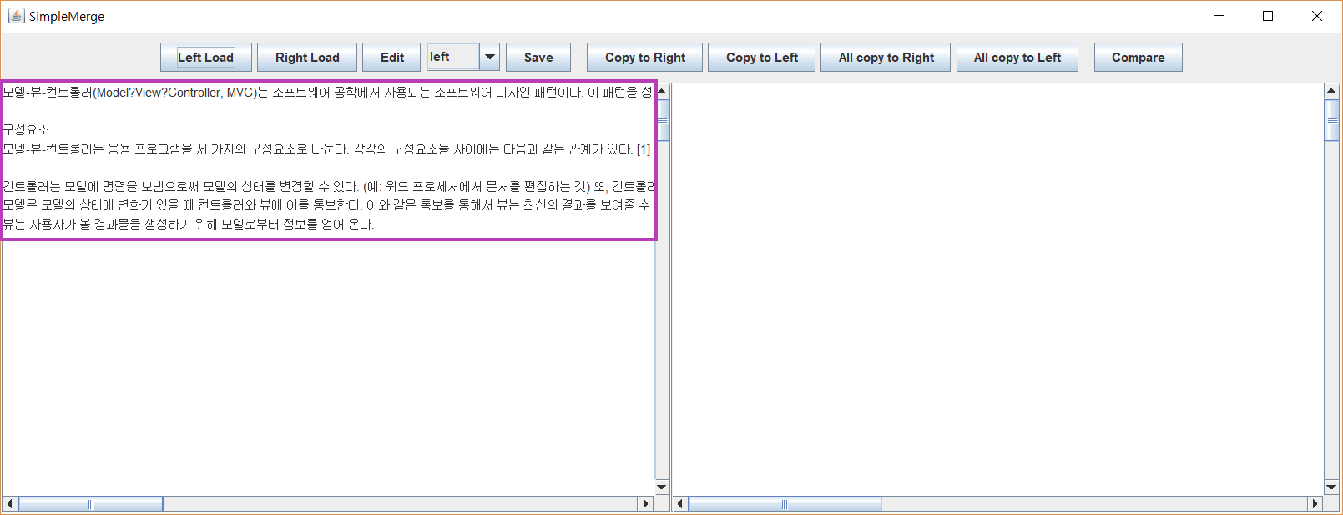

3) Left Load Complete

- selected file’s contents recorded in left panel.

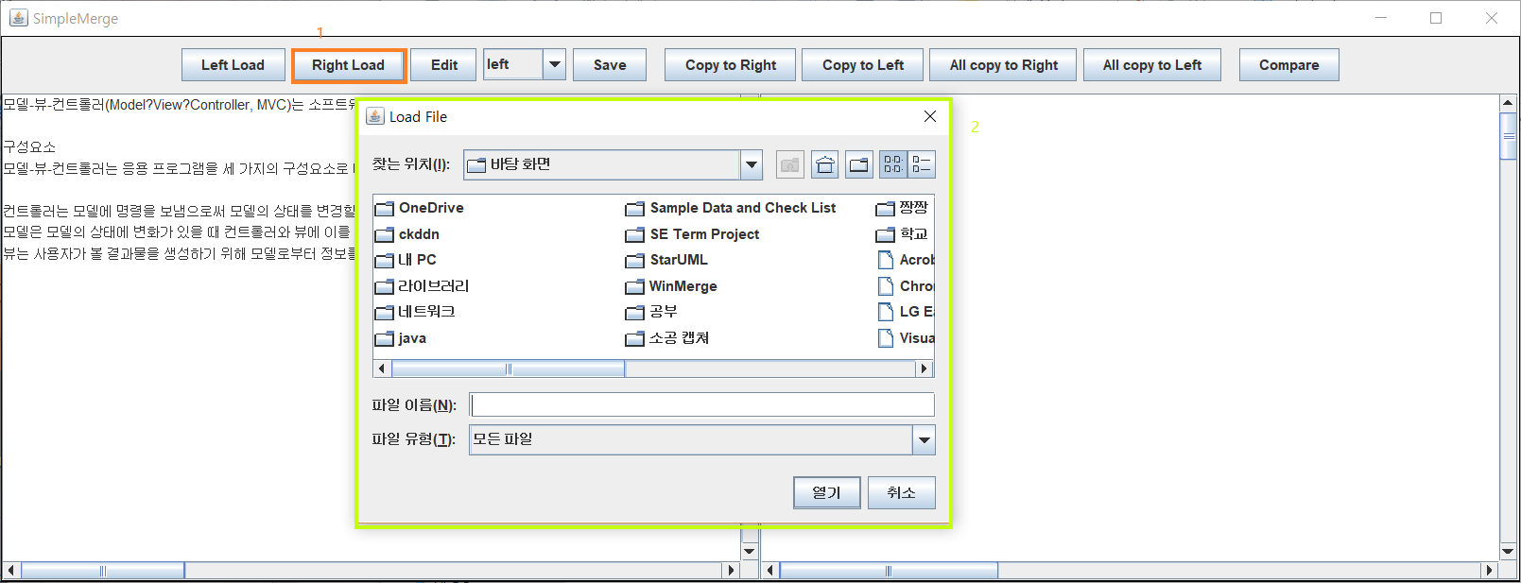

4) Press Right Load Btn

- Press “Right Load” button.

- FileChooser frame for load file to right panel evoke.

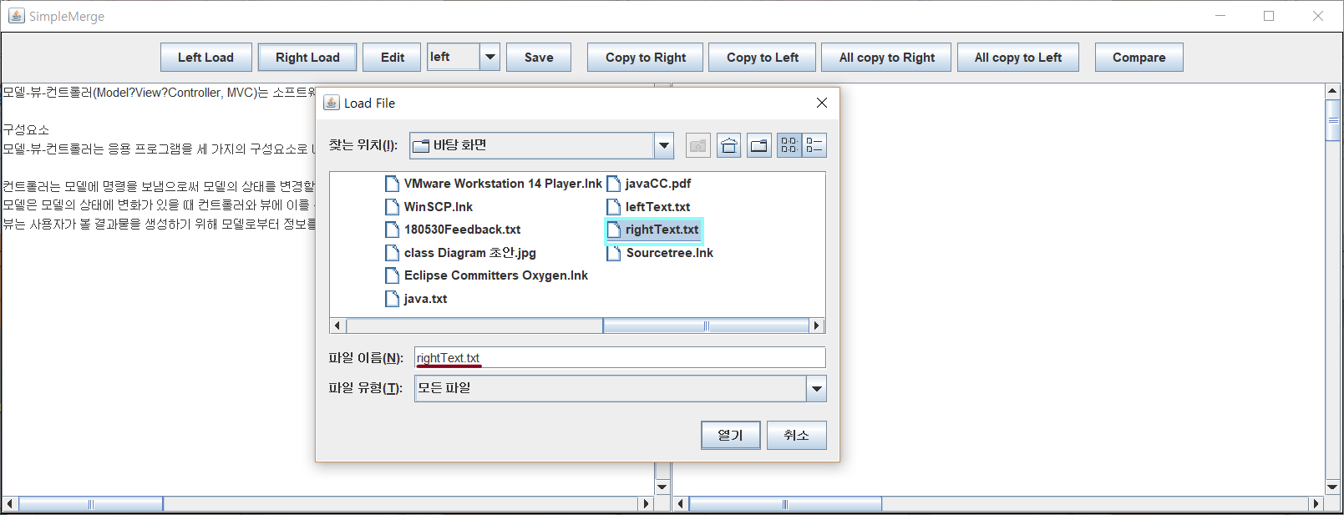

5) Select File and Press Open Btn (Right)

- select file from filechooser frame.

- selected file name recorded in filename label.

- press “열기” button. (same with sequence 2)

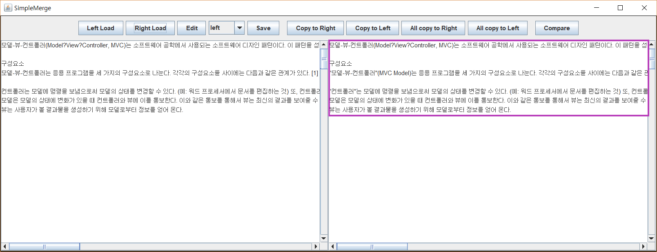

6) Right Load Complete

- selected file’s contents recorded in right panel.

**3. Edit**

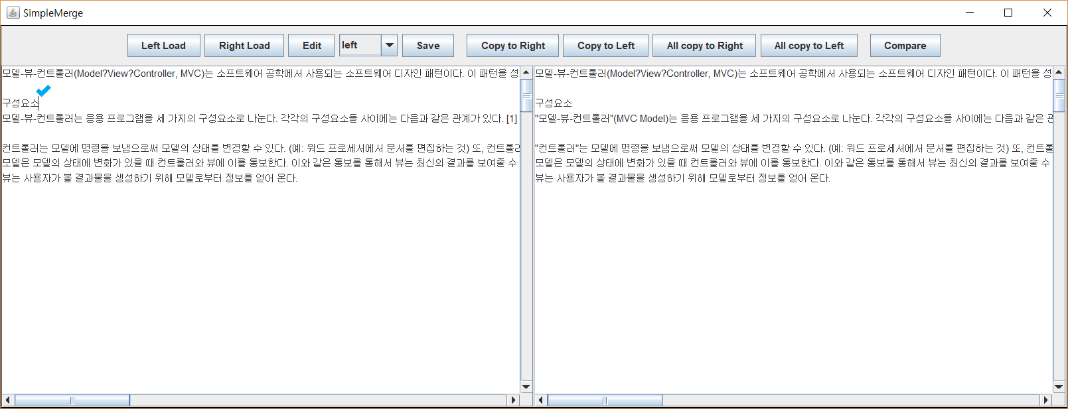

1) Default (Editable)

- Default mode of panel, sight of editable, is editable.

- if you click panel, the cursor will blink.

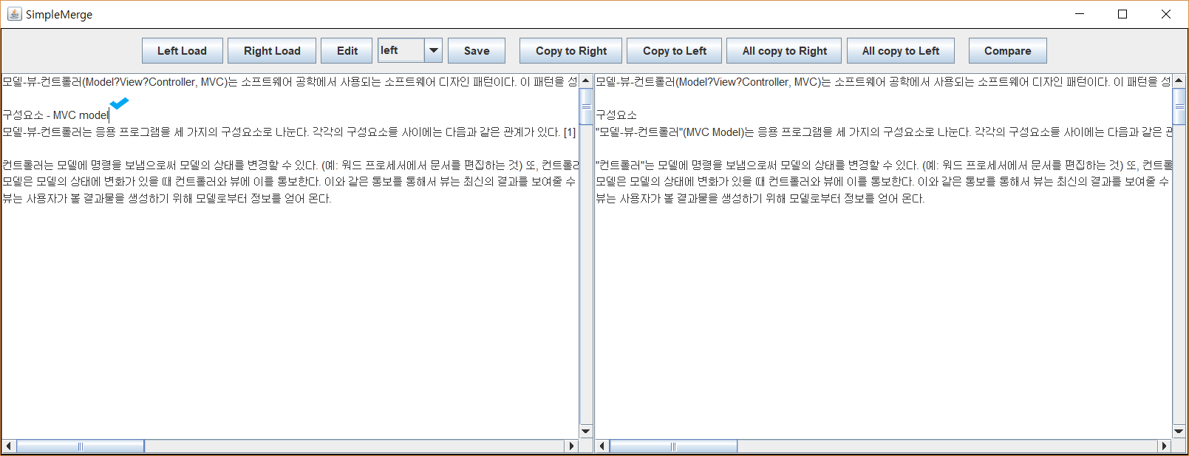

2) Edit contents

- input strings are recorded in the selected panel.

- cursor still blinks because the panel is editable.

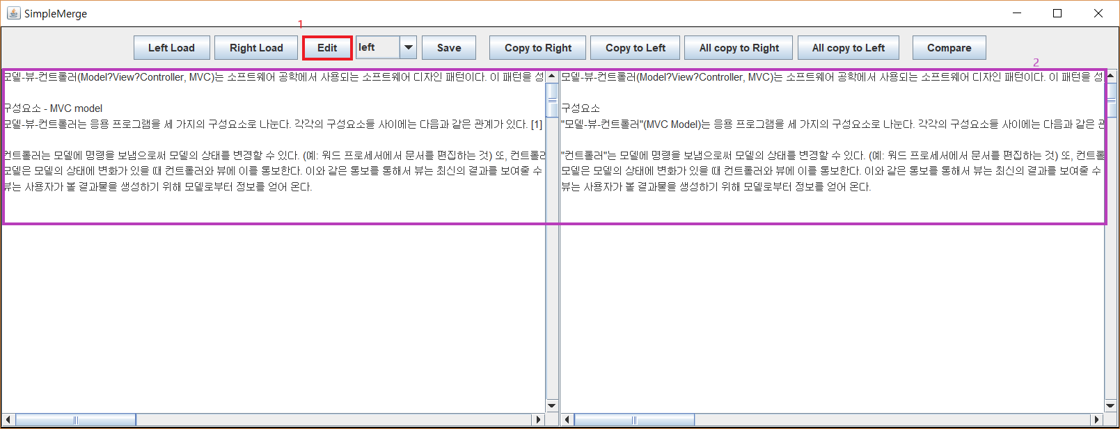

3) Press Edit Btn when the panel is Editable (set Uneditable)

- press the “Edit” button.

- panel will not be selected.

- cursor disappears and panel is not editable.

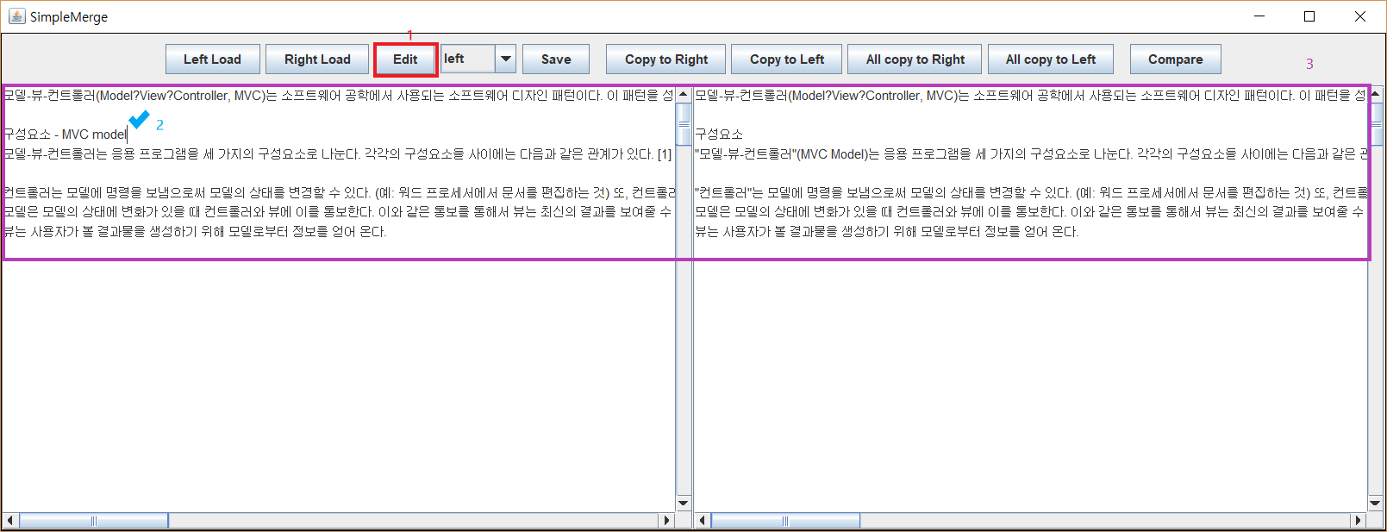

4) Press Edit Btn when the panel is Uneditable (set Editable)

- press the “Edit” button.

- user can edit is now toggled.

- cursor appears and panel is editable.

4. Save

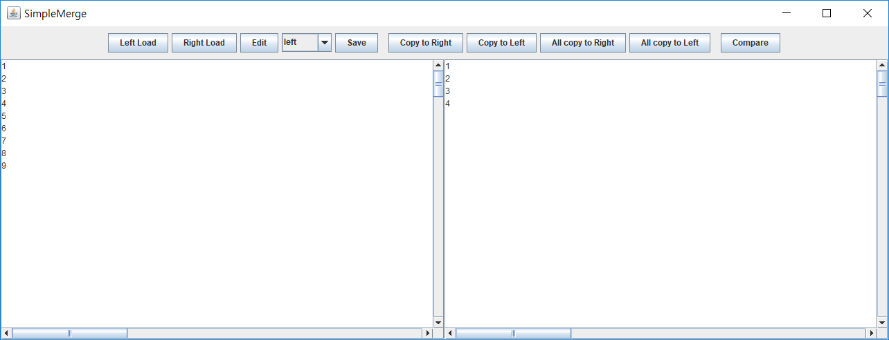

1. Press Save Btn, Save Option = left, right

- When you press the Save button, a window will pop up informing you that the save is complete.

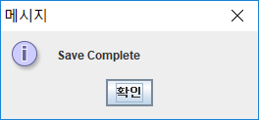 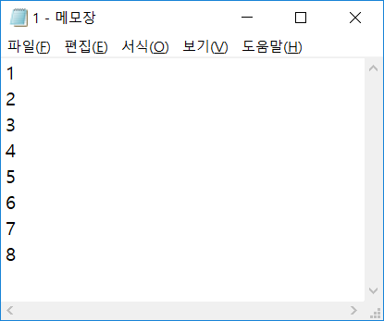

1. Press Save Btn, Save Option = left as, right as

- When you press the Save button, JFileChooser window will pop up.

- Select the location you want to save and write the file name.

- Click save.

- Window will pop up informing you that the save is complete.

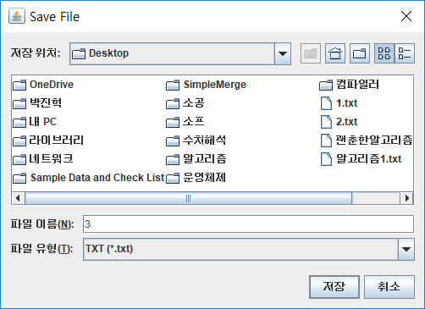 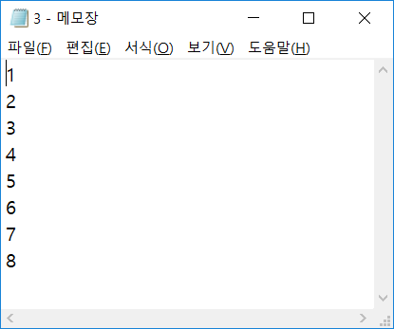

3) Exceptional Situation Handling ( Same name file exists )

- If a file with the same name exists in the location you want to save, a window will pop up asking you to overwrite or cancel.

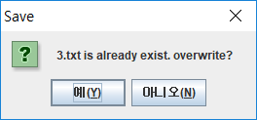 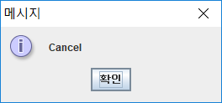

5.

6.

**V. Aftermath**

**1. Performance Analysis**

1) Usability

GUI allows user to utilize the program intuitively, without learning beforehand any kinds of logic applied in the implementation.

2) Distribution

Final version of the program was completed in JAVA language, and compiled via eclipse tool. Following program is executable in any hardware system supporting a JVM system.

3) Accuracy of Features

All the required testing conditions are fulfilled, major features are satisfied without errors.

4) Additional Feature

**2. Limitations**

1) Design Structural Flaw

All logical functions needed in the Compare feature of the program was implemented in the CompareEventHandler class. This was due to the fact that in the early stages of the project, the current CompareEventHandler class was the component Comparer, which was meant to devise comparing features. However, after adapting GUI components, the Comparer component changed into a class that handles events relating to the compare feature requested by the user.

Therefore it would have been a more optimal solution to implement a separate class that dealt with purely logical functions needed by compare, and the CompareEventHandler requesting outside the logical implementation. This would have meant more precise separation of the Model and Controller, by separating functions such as the LCS algorithm outside the handler, as a part of Model.

2) Comparison to WinMerge Program